**Data Types, Operators and Expressions in C++**

**LAB #02**



**Spring 2021**

**CSE102L Computer Programming Lab**

Submitted by: Maaz Habib

Reg No: 20pwcse1952

Class Section: C

“On my honor, as student of University of Engineering and Technology, I have neither given nor received unauthorized assistance on this academic work.”

Student Signature: ______________

Submitted to:

**Engr. abdullah hamid**

May 1, 2021

Department of Computer Systems Engineering

University of Engineering and Technology, Peshawar

**Lab Objective(s):**

* To be familiar with different data types, operators and expressions in C++.

**Task 01:**

**Tittle:**

Write a program that takes the temperature in Fahrenheit and convert it into Celsius and kelvin:

**K=C+273**

**C= (F-32)/1.8**

**Code:**

|  |
| --- |
| #include <iostream>  using namespace std;  /*following code is written and compiled in code::Blocks  IDE*/  int main()/*library for writing the output to console  window*/  { //start the program  //variable declaration  float F, C, K;  cout << "enter the temperature in Fahrenheit" << endl;  cin>> F;  //assign values to variable  C=(F-32)/1.8;  K=C+273;  /*calculation using mathematical formula*/  cout << "given temperature in Celsius" << endl;  cout <<C<<endl;  cout << "given temperature in Kelvin" << endl;  cout <<K;  return 0;  //end the program  } |

**Output:**

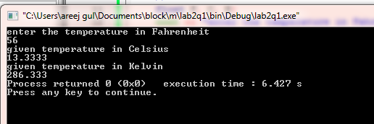

**Task 02:**

**Tittle:**

Write the C++ code that takes the integer a, b, c, d and e from the user and display the output according to the following equation.(a3+b2-d/b)/a(b+c(e+a)/b)-10

**Code:**

|  |
| --- |
| #include <iostream>  /*following code is written and compiled in code::Blocks  IDE*/  using namespace std;  int main()/*library for writing the output to console  window*/  { //start the program  //variable declaration  int a, b, c, d, e;  cout << "input integer a"<< endl;  cin>> a;  cout << "input integer b"<< endl;  cin>> b;  cout << "input integer c"<< endl;  cin>> c;  cout << "input integer d"<< endl;  cin>> d;  cout << "input integer e"<< endl;  cin>> e;  //assign values to variable  int res=((a*a*a+b*b-d)/b)/(a*(b+c*(e+a)/b)-10);  /*calculation using mathematical formula*/  //display result  cout <<"value of equation"<<endl;  cout <<res;  return 0;  //end the program  } |

**Output:**

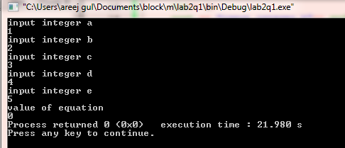

**Task 03:**

**Tittle:**

Write a program to declare two integers and one float variables then initialize them to 10,15,and 12.6.also print the variable values on the screen.

**Code:**

|  |
| --- |
| #include <iostream>  /*following code is written and compiled in code::Blocks IDE*/  using namespace std;  int main()/*library for writing the output to console window*/  { //start the program  int first;  int second;  float third;  cout<<"enter first number";  cin>>first;  cout<<"enter second number";  cin>>second;  cout<<"enter third number";  cin>>third;  cout<<"display first number"<<endl;  cout<<first<<endl;  cout<<"display second number"<<endl;  cout<<second<<endl;  cout<<"display third number"<<endl;  cout<<third<<endl;  return 0;//end the program  } |

**Output:**

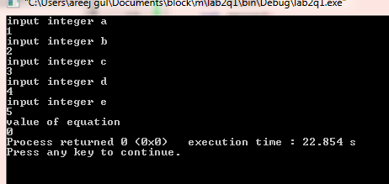

**Task 04:**

**Tittle:**

Write a C++program to prompt the user to input 3 integer values and print these values in forward and reverse order.

**Code:**

|  |
| --- |
| #include <iostream>  using namespace std; /*following code is written and compiled in code::Blocks IDE*/  int main()/*library for writing the output to console window*/  { //start the program  Enter integer a,b,c  int a,b,c;  cout<<"enter value of a";  cin>>a;  cout<<"enter value of b";  cin>>b;  cout<<"enter value of c";  cin>>c;  //display result in forward order  cout<<"print values in forward bias"<<endl;  cout<<a<<endl;  cout<<b<<endl;  cout<<c<<endl;  //display result in reverse order  cout<<"print values in reverse bias"<<endl;  cout<<c<<endl;  cout<<b<<endl;  cout<<a<<endl;  return 0;  //end the program  } |

**Output:**

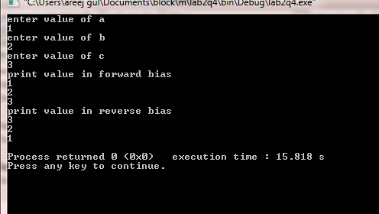

**Task 05:**

**Tittle:**

Write a program to swap two variables with and without using third variable.

**Code:**

|  |
| --- |
| #include <iostream>  using namespace std; /*following code is written and compiled in code::Blocks IDE*/  int main()/*library for writing the output to console window*/  { //start the program  Enter integer a,b  int a,b;  int z;  cout<<"enter first number a : ";  cin>>a;  cout<<"enter second number b : ";  cin>>b;  //assign values to variables  swap(a,b);  cout<<" without using third variable after swapping numbers are : ";  cout<<a<<" "<<b<<endl;  z=a;  a=b;  cout<<"with using third variable:"<<endl;  cout<<z<<" "<<a;  //display result  return 0;  //end the program  } |

**Output:**

